



## Module (CSS and CSS 3) - 2

ASSIGNMENT

**Name :-** Mitesh Bhavsar



**Module (CSS and CSS 3) – 2**

***1.What are the benefits of using CSS?***

**ANS:**

**CSS handles the look and feel part of a web page. Using CSS, you can control the color of the text, the style of fonts, the spacing between paragraphs, how columns are sized and laid out, etc. CSS saves time − You can write CSS once and then reuse the same sheet in multiple HTML pages.**

**There are a number of benefits of CSS**

### *1) Faster Page Speed*

**More code means slower page speed. And CSS enables you to use less code. CSS allows you to use one CSS rule and apply it to all occurrences of a certain tag within an HTML document.**

### *2) Better User Experience*

**CSS not only makes *web* pages easy on the eye, it also allows for user-friendly formatting. When buttons and text are in logical places and well organized, user experience improves.**

### *3) Quicker Development Time*

**With CSS, you can apply specific formatting rules and styles to multiple pages with one string of code. One cascading style sheet can be replicated across several website pages. If, for instance, you have product pages that should all have the same formatting, look, and feel, writing CSS rules for one page will suffice for all pages of that same type.**

### *4) Easy Formatting Changes*

**If you need to change the format of a specific set of pages, it’s easy to do so with CSS. There’s no need to fix every individual page. Just edit the corresponding CSS stylesheet and you’ll see changes applied to all the pages that are using that style sheet.**

### *5) Compatibility Across Device*

### Responsive web *design* matters. In today’s day and age, web pages must be fully visible and easily navigable on all devices. Whether mobile or tablet, desktop, or even smart TV, CSS combines with HTML to make responsive design possible.

### *Example :*

### 

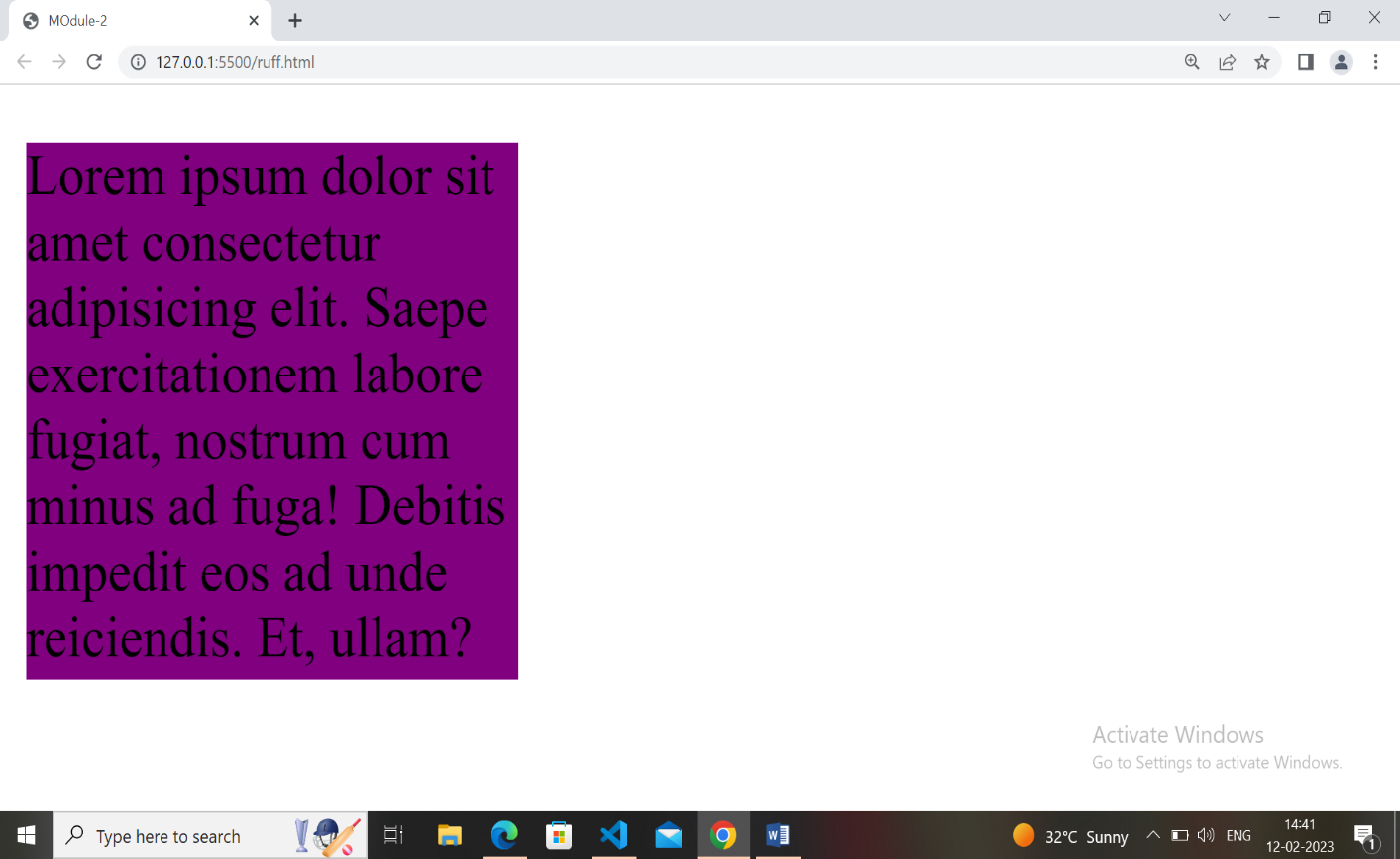

***2. What are the disadvantages of CSS?***

**ANS:**

***Disadvantages of CSS***

**There are a few downsides while using CSS. One must know these disadvantages so that he or she is aware and takes care of them while designing a website.**

**1. Confusion due to many CSS levels**

**Beginners are more vulnerable to this issue. They might get confused while opting to learn CSS as there are many levels of CSS such as CSS2, CSS3, etc.**

**2. Cross-Browser Issues**

**Different browsers work differently. So, you have to check that changes implemented in the website via CSS codes are reflected properly among all browsers.**

**3. Security Issues**

**Security is important in today’s world driven by technology and data. One of the major disadvantages of CSS is that it has limited security.**

**4. Extra Work for Developers**

**Design services are required to consider and test all CSS codes across different browsers for compatibility. Due to developers testing compatibility for different browsers, their workload increases.**

**Overall, we can say that if you are passionate about web development, try to learn HTML and CSS. For device compatibility, learn the Bootstrap framework as well. Though you might see some disadvantages of CSS, many advantages counter them and ensure that** **your web development process is smooth and efficient.**

***3 . What is the difference between CSS2 and CSS3?***

**ANS:**

## Here are the major differences between CSS 2 and CSS 3

## 🡪 Unlike CSS2, which was comprised of a single document, CSS3 has Its specifications divided into many individual modules, Which makes CSS3 a whole lot easier to handle.

## *4. Name a few CSS style components*

## ANS:

## *The components of CSS style are:-*

## • Selecter:

## HTML element name, id name, class name.

## • Property:

## It's like an attribute such as background color,font-size,position,text-align,color,border etc.

## • Values:

## which defines property or values allocate for properties.

### *Example :*

### 

## 

## *5. What do you understand by CSS opacity?*

## ANS:

## The opacity CSS property sets the opacity of an element.

## Opacity is the degree to which content behind an

## element is hidden, and is the opposite of transparency.

### *Example :*

## 

## 

## *6. How can the background color of an element be changed?*

## ANS:

## *How to Change a Div Background Color:-*

## • Add a CSS class to the div you'd like to change. First,

## find the div in your HTML code and add a class

## to the opening tag. ...

## • Add the new class selector to your CSS code. Next, head

## over to your CSS code and add your new class selector.

## • Choose a new background color.

## *Example :*

## 

## 

## 

## *7. How can image repetition of the backup be controlled?*

## ANS:

## To control the repetition of an image in the background, use the background-repeat property. You can use no-repeat value for the background-repeat property if you do not want to repeat an image, in this case, the image will display only once.

## *8. What is the use of the background-position property?*

## ANS:

## The background-position property sets the starting position of a background image.

## Tip: By default, a background-image is placed at the top-left corner of an element, and repeated both vertically and horizontally.

## *Example :*

## 

## 

## 

## *9. Which property controls the image scroll in the background?*

## ANS:

## The background-attachment property sets whether a background image scrolls with the rest of the page, or is fixed.

## *10. Why should background and color be used as separate properties?*

## ANS:

## There are two reasons behind this: It enhances the legibility of style sheets.

## The background property is a complex property in CSS, and if it is combined with color, the complexity will further increase.

## *11. How to center block elements using CSS1?*

## ANS:

## With css the way to center anything that's a block level element is with the margin property. One of the values of margin is auto and by setting auto on the left and right margin our block level element will center itself.

## *12. How to maintain the CSS specifications?*

## ANS:

## If you've followed this series from the beginning , we discussed about the [HTML Specification](https://dev.to/ziizium/the-html-specification-4epa) which is sort of a rule book that tells browser vendors how to implement HTML Elements and Tags.

**The CSS Specification is no different but with a different approach with the advent of CSS3.**

**The Specification defines how CSS properties should be implemented by browser vendors along with detailed algorithms, code samples and tabular information.**

**The Specification also include:**

* **The syntax and data types of the language**
* **Detailed explanation on CSS Selectors**
* **How you can assign values to properties**
* **The Cascade (the "C" in CSS)**
* **How inheritance works**
* **The Box Model e.t.c**

**Explanation on some of these topic are short and easy to understand while others are explained in great detail.**

**The Specification also specify how stylesheets can be included in your web document and how to target specific media e.g print or screen.**

**The CSS Specification prior to CSS3 was a single Specification, CSS3 on the other hand is divided into Modules which are Independent Specifications that can be worked on by different author(s) at different paces, that's why we have Selector Level 3 Specification, CSS Color 4, CSS Backgrounds and so on. Some of these modules are revisions of CSS2.1, and some are newly created, but all fall under the banner of CSS3.**

**The Specification should be your guide if you need to understand how a specific property or feature works behind the scene and how it works with other CSS properties. And if you are comfortable reading algorithms you won't get bored reading the CSS Specification.**

[**The Specifications can be accessed online**](https://drafts.csswg.org/)**along with the author(s) name and when its was last updated.**

***13. What are the ways to integrate CSS as a web page?***

## ANS:

***CSS can be added to HTML documents in 3 ways:***

**• Inline - by using the style attribute inside HTML elements.**

**• Internal - by using a <style> element in the <head>**

**section.**

**• External - by using a <link> element to link to an external**

**CSS file.**

## *Example :*

## 

## 

## 

## *14. What is embedded style sheets?*

## ANS:

## *Embedded Stylesheet*

## It allows you to define styles for a particular HTML

## document as a whole in one place. This is done by

## embedding the <style></style> tags containing the CSS

## properties in the head of your document.

## 

## *15. What are the external style sheets?*

## ANS:

## *External Stylesheet*

## style sheet is a separate CSS file that can be

## accessed by creating a link within the head section of the

## webpage. Multiple webpages can use the same link to

## access the stylesheet. The link to an external style sheet

## is placed within the head section of the page.

## *Example*

## 

## *16.What are the advantages and disadvantages of using external style sheets?*

## ANS:

## *External style sheets have the following advantages over*

## *internal and inline styles*

## • one change to the style sheet will change all linked

## pages.

## • you can create classes of styles that can then be used on

## many different HTML elements.

## • consistent look and feel across multiple web pages.

## 

## *17. What is the meaning of the CSS selector?*

## ANS:

## A CSS selector is the first part of a CSS Rule. It is a

## pattern of elements and other terms that tell the browser

## which HTML elements should be selected to have the

## CSS property values inside the rule applied to them.

## 

## *18. What are the media types allowed by*

## *CSS?*

## ANS:

## → continuous or paged.

## → visual, audio, speech, or tactile.

## → grid (for character grid devices), or bitmap.

## → interactive (for devices that allow user interaction), or

## static (for those that do not).

## → all (includes all media types)

## 

## *19. What is the rule set?*

## ANS:

## A collection of rules or signatures that network

## traffic or system activity is compared against to

## determine an action to take—such as forwarding or

## rejecting a packet, creating an alert, or allowing a

## system event.

## *20. Create Layouts..?*

## ANS:

## 

## 

## 

## 

## 

## 

## 